**Explanatory note**

**Topic of the project:** Role-play game using Telegramm-bot.

**Annotation:** a console application, where all the user actions would be performed in Telegramm chat. There is also a database to store all the data to change game content easily.

**Central repository addres**s: <https://github.com/VGilmanova/teamProject>

**Members of the team and their roles:** Maria Alchikova (Telegramm client), Venera Gilmanova (database, content).

**List of classes:**

**Project 1. DBClasses. Classes library.**

1. 3 Classes of DB entities (Location, Answer and Game)
2. Folder Migration with migration classes and class Configuration
3. Repository class with methods.

**Project 2.** Telegramm Client

**Program interface:**

**At this console administrator can see how many people are now in the game and also game can be stopped from here.**

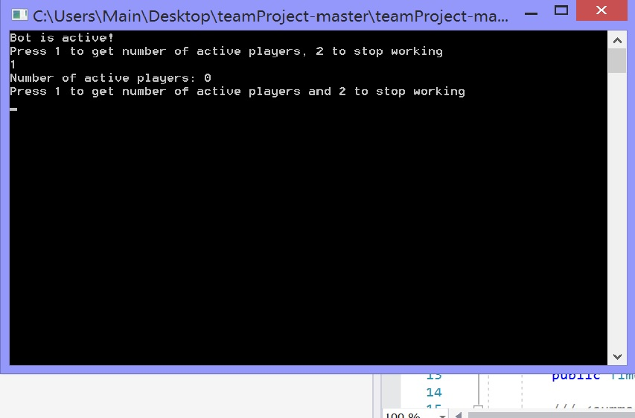

**Test cases:**

**Normal game:**

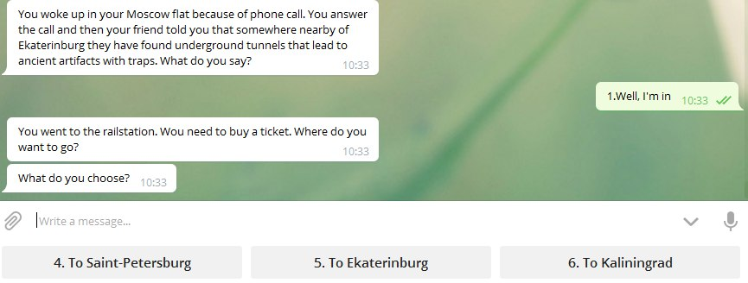

**Sending the bot incorrect message:**

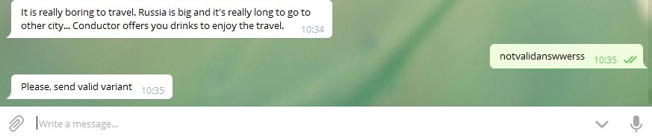

**Sending the bot sticker or any other kind of message:**

